**Git Branching Command**

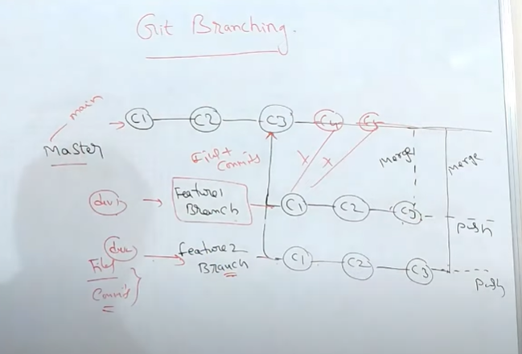

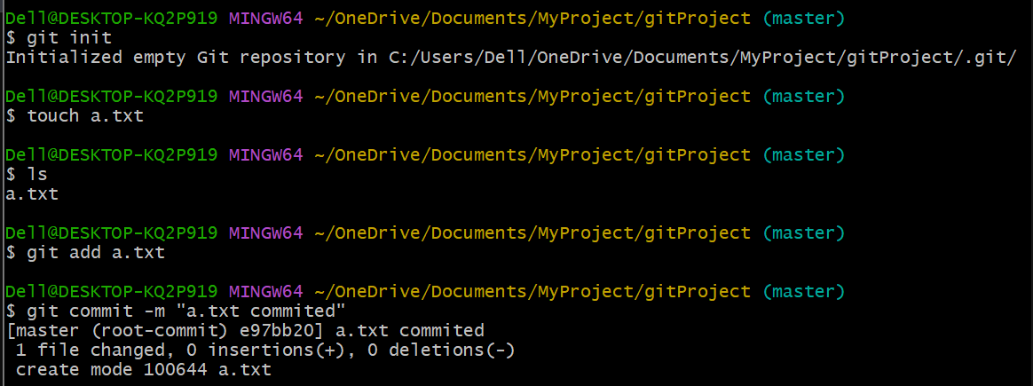First create a file , add them to staging area and commit them . Then

1. To view the available branches :

$ git branch

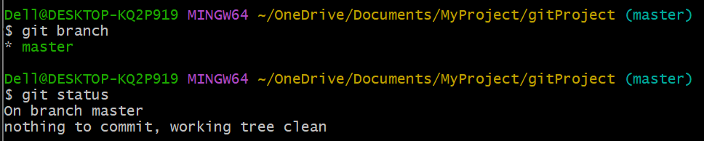 $ git status

where * represents active branch

1. To create new branch

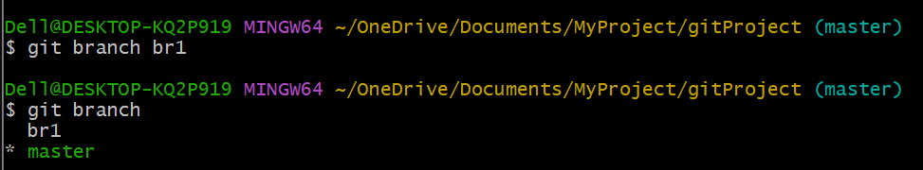

1. To Switch from one branch to another branch

git checkout 🡪 discard unstaged changes in working directory

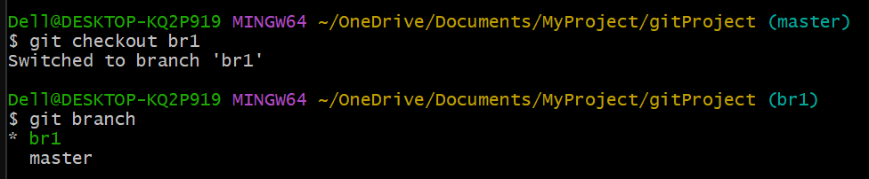

1. Creating and switching to branch in single command

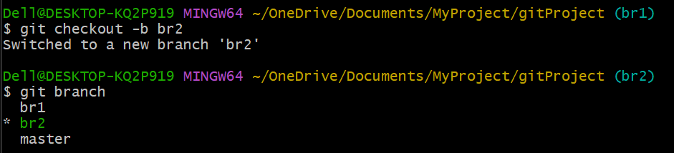$ git checkout -b ‘branchname’

